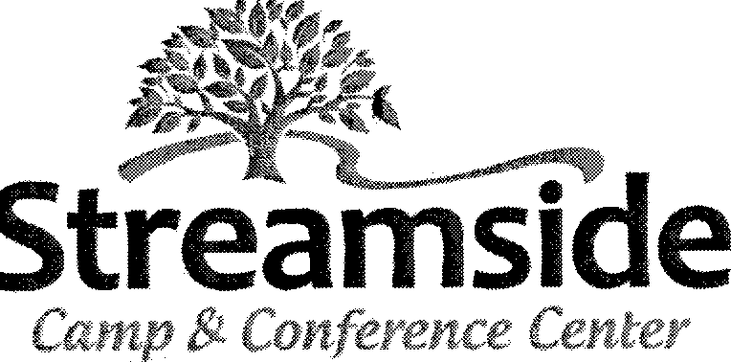

In consideration of being allowed to participate in Camp and Camp activities, the undersigned parent acknowledges, understands and agrees that all listed children:

1. Participation in Camp and Camp activities includes possible exposure to
and illness from infectious diseases including COVID-19, any and all current and/or future variants and/or related conditions and/or illness. While particular rules and safety measures may reduce this risk, the risk of serious illness and/or death does exist.
2. Guest et al understands and agrees that Guest's et al use of Camp's facilities and premises includes possible exposure to COVID-19, any and all current and future variants and/or any related condition and/or illness, the result of which may be both serious and minor, including but not limited to cough, fever, pneumonia, hospitalization and death. Guest et al know and freely assumes all such risks, known and unknown, even if arising from the negligence of Camp and assumes responsibility for participating in Camp and Camp activities.
3. Guest et al recognizes, understands and agrees that Camp assumes no responsibility for any liability, damage, or injury relating or resulting from COVID-19 and any and all current and future variants and/or related conditions and/or illness, that may be caused by the negligent acts or omissions of Camp committed prior to, during or after use of the Camp's premises and facilities by Guest et al.
4. Guest et al willingly agrees to follow and comply with all safety measures instituted by the Camp to help prevent infection or the spread of COVID-19 and any and all current and/or future variants and/or related conditions and/or illness.
5. Guest et al, for itself and on behalf of its heirs, assigns, personal representatives and next of kin, hereby agrees to indemnify, defend and hold harmless Camp, its successors, assigns, officers, directors, trustees, faculty, employees, volunteers and officials, from any and all claims, demands, actions or suits, including reasonable attorney's fees, arising from any sickness, injuries, disabilities, death or damage to person or property, relating to or resulting from COVID-19 and any and all current and future variants, related conditions and/or illness regardless of cause or fault, as a result of Guest's et al voluntary decision to participate in Camp or Camp activities, whether arising from an act or omission of Camp or otherwise.
Parent Signature ____Date_______________
Parent Name (Printed)_________________________________________________
Date of Event_______________________

Child(ren)’s Name(s) (printed)
1_______________________________ 6_________________________________
2_______________________________ 7_________________________________
3_______________________________ 8_________________________________
4_______________________________ 9_________________________________
5_______________________________ 10________________________________

